Hudson Township Master Plan
Adopted by the Hudson Township Planning Commission on
June 15, 2015 by Resolution #R2015-06

Acknowledgements

The author of this Master Plan would like to thank the members of the Hudson Township Planning Commission for their hard work and incredible patience throughout the planning process, the staff at ENP and Associates for their diligence in obtaining the facts, and the residents of Hudson Township for their vision of the future.

Table of Contents
Chapter 1 - Introduction 3
Chapter 2 - Hudson Township Existing Conditions 6
Chapter 3 - Planning Goals and Objectives 14
Chapter 4 - Future Land Use 16
Chapter 5 - Implementation 19
Appendix 26

Tables of Figures
Table 1- Population Hudson Township and Surrounding Communities, 1970-2010 | 7
Chart 1- Review of Neighboring Community Plans ……………………………… | 10
Map 1- Hudson Township Opportunities and Constraints ………………………. | 13
Map 2 - Future Land Use ………………………………………………………… | 18

Chapter 1 - Introduction

This document is the Hudson Township Master Plan, referred to throughout as the Master Plan. This is a policy document that guides future growth and land management in the Township. The Master Plan serves as a vision for the future of Hudson Township based on existing and predicted conditions, and a tool to preserve and enhance the public health, safety, and general welfare of the Township.

Purpose
The Master Plan is a guide describing the Hudson Township Planning Commission’s strategies for land use. The Master Plan outlines steps to implement the vision set forth by the Planning Commission as determined through community engagement and review of existing conditions. The following table is a summary of what a Master Plan does and does not do:

The Master Plan Does… | The Master Plan Does Not…
Provide a vision for the Township | Serve as an exact blueprint for the Township
Provide a framework for evaluating zoning petitions | Fix development issues which are made on a case-by-case basis
Allow for amendment and flexibility when conditions change | Mandate future actions
Describe general land uses in the Township | Prescribe land use for specific parcels
Provide a guide for future land use discussions | Substitute for inclusive community engagement processes

Planning is an ongoing process that strives to answer several questions about Hudson Township. The Master Plan assesses the current conditions in the Township, assists in developing a vision for the community, and explores opportunities to achieve that vision. The following questions are answered in this document:

What do we have? This question can be answered by researching and analyzing existing conditions such as roads, land use, and environmental resources, and identifying issues raised by these conditions.

What do we want? This question can be answered by exploring local aspirations and the future vision residents have about their community.

How do we get there? This question can be answered by reviewing alternative strategies that reach for the vision set forth by the community.

Is the Master Plan Working? This question can be answered by having periodic assessments of the effectiveness of the strategies outlined in the Master Plan.

Authority
The Hudson Township Planning Commission, under the authority of the Michigan Planning Enabling Act (P.A. 23 of 2008) and the Michigan Zoning Enabling Act, (P.A. 110 of 2006) prepared this Master Plan. The Acts provide for the development of plans by a Planning Commission for the purposes:

‘…to promote public health, safety, and general welfare: to encourage the use of resources in accordance with their character and adaptability; to avoid the overcrowding of land by buildings or people; to lessen congestion on public roads and streets… and to consider the character of each Township and its suitability for particularly uses judged in terms of such factors as the trend in land and population development.’ (MZEA, Sec. 125.3201)

The Master Plan is not a regulatory document, but a ‘policy plan’ to be implemented through regulatory tools. For example, the Master Plan is not a zoning ordinance, but recommendations and policies are used to update the Hudson Township Zoning Ordinance. The Master Plan will undergo a complete review and update every five years in accordance with State enabling legislation.

Planning Process
Hudson Township has been operating under the Master Plan adopted through 2010. In 2013, the Township began to update its Zoning Code and Master Plan with help from ENP and Associates (Ann Arbor, MI). The Planning Commission has worked to prepare a new plan that integrates the Township’s Zoning Code, adopted in 2014, which lays the groundwork for future ambitions, and to meet statutory requirements. The Master Plan is a reflection of the future goals and ideas developed by the Planning Commission and residents of the Township.

A citizen survey was administered at the beginning of 2014 to understand dominant local issues. The following issues were identified as priorities:

- Agricultural land preservation and protection
- Road and infrastructure repairs
- Job growth
- Improved Tax Base
- Recreational Area Improvements

Surrounding community plans were reviewed, and a new Zoning Code was drafted and adopted during the development of the Master Plan, which assisted in creating a vision for the Township. An additional citizen survey was administered in mid-2014 to clarify priorities and understand possible action steps the Planning Commission should take to achieve the Township goals.

A draft Master Plan was reviewed by local officials in late 2014. Revisions to the draft plan were undertaken and a revised plan was presented at a public hearing, held by the Planning Commission. The Master Plan was finalized and adopted by resolution by the Planning Commission on June 15, 2014.

Elements of the Plan
The Master Plan is divided into the following chapters:

Chapter 2 - Existing conditions in the Township, surrounding community plans, and current opportunities and constraints facing the Township (page 6)

Chapter 3 - Associated goals and initiatives that address priorities identified through citizen input (page 14)

Chapter 4 - The planned future land use pattern for the Township (page 16)

Chapter 5 – Implementation of initiatives (page 19)

Appendix - Background studies that review existing conditions and trends in the Township and citizen survey full results (page 26)

Chapter 2 - Hudson Township Existing Conditions

Physical Location
Hudson Township was authorized as a Township in 1836 by an act of the State legislature. The boundaries of the Township have changed slightly from the original borders, established in 1836. Hudson Township is located on the western boundary of Lenawee County, surrounded by Rollin Township to the north, Dover Township to the east, Medina Township to the south, and Pittsford Township in Hillsdale County to the west. The state line with Ohio lies six miles south of Hudson Township.

The City of Hudson is a politically autonomous incorporation within Hudson Township. The Village of Clayton straddles the Hudson and Dover Township lines.

Hudson Township is approximately 18 miles west of Adrian, the largest city in Lenawee County, 30 miles south of Jackson, and 16 miles east of Hillsdale. These urban areas provide a significant number of jobs for the residents of Hudson Township.

Additionally, Hudson Township is approximately 20 miles south of the Michigan International Speedway and the Irish Hills recreational area. These tourist and recreational attractions bring travelers through Hudson Township.

Population Trends
Hudson Township has seen steady and incremental growth since 1970. The most recent decennial census showed a slight decrease in population of 5%. However, the overall trend is still increasing, as the net population gain from 1990 to 2010 is 24 people, despite the loss of residents over the past decade. Table 1 on the following page shows the population trends for Hudson Township and surrounding communities. Hudson Township’s 50-year trend is consistent with nearby communities and remains on an upward trajectory. The City of Hudson and Village of Clayton have experienced downward trends in population.

Hudson Township’s population has aged in the past decade. The population in 2010 is older than in 2000 and the number of households with children under 18 has decreased. These data indicate that families are choosing to stay in Hudson Township, but new families with children are not moving to the Township. As the population continues to age population trends could reverse. Older residents could choose to move to other communities or to live in Hudson part-time rather than stay in Hudson Township.

Table 1- Population Hudson Township and Surrounding Communities, 1970-2010. Source: US Census 2010

Area | 1970 | 1980 | 1990 | 2000 | 2010 | 1970-2010 Change
 |  |  |  |  |  | Number | Percent
Hudson Twp | 1,145 | 1,384 | 1,300 | 1,403 | 1,324 | 179 | 15.6%
Dover Twp | 1,259 | 1,703 | 1,608 | 1,634 | 1,663 | 404 | 32.1%
Medina Twp | 1,301 | 1,455 | 1,368 | 1,227 | 1,090 | (211) | -16.2%
Pittsford Twp | 1,486 | 1,550 | 1,595 | 1,600 | 1,603 | 117 | 7.9%
Rollin Twp | 2,361 | 3,012 | 2,891 | 2,721 | 2,840 | 479 | 20.3%
City of Hudson | 2,546 | 2,545 | 2,580 | 2,499 | 2,307 | (239) | -9.4%
Village of Clayton  (Dover Twp) | 470 | 396 | 384 | 326 | 344 | (126) | -26.8%
Village of Clayton  (Hudson Twp) | 196 | 166 | 181 | 173 | 173 | (23) | -11.7%
Hillsdale County | 34,742 | 42,071 | 43,431 | 46,527 | 46,688 | 11,946 | 34.4%
Jackson County | 126,488 | 146,024 | 142,806 | 158,422 | 160,248 | 33,760 | 26.7%
Lenawee County | 77,789 | 89,948 | 91,476 | 98,890 | 99,892 | 22,103 | 28.4%

Land Use and Physical Features
Hudson Township is located on a gently rolling topography with few marsh or wetland areas. There are two major bodies of water in the Township, Posey Lake on the northern border, and the man-made Lake Hudson in the southeast corner. Posey Lake has been nearly fully developed while Lake Hudson is used as a State Recreation Area.

Bean Creek and Bear Creek, which was dammed to form Lake Hudson, are the two major stream systems in the Township. Most of the Township drains into Bean Creek, which traverses from the northwest to the southwest corners of the Township.

Soils are generally not suitable for new construction, though fewer limitations exist near the City of Hudson. Most soils are best suited for agricultural activities, particularly in the central portions of the Township.

Farming and agriculture are dominate land uses in Hudson Township. Single-family homes account for the second-most acreage in the Township. Residential subdivisions exist on Posey Lake and just south of the City of Hudson.

Commercial needs are met predominately by the City of Hudson. Most commercial land in the Township is located along US-127 on the western border, though additional commercial is located at the intersections of Posey Lake and Beecher, Cadmus and Munson, and M-34 and M-156. These commercial uses include automotive dealerships, restaurants, farm equipment dealerships, grocery stores, taverns and other similar uses.

The Township has relatively few existing industrial land uses. These are located north, south, and east of the City of Hudson and includes a grain elevator. The City of Hudson has substantial industrial development, especially along M-34 east of the central business district.

Public and semi-public land uses include the Lake Hudson Recreation Area, the small cemetery at Munson and Lowe Roads, the Grange Hall on M-34, the golf course, and the American Legion Hall on Cadmus Road.

Transportation
Hudson Township is well served by transportation routes. US-127 runs north and south along the western boundary of the township providing linkages north to the Jackson area. US-127 also links other transportation arteries including US-12, Interstate 94, and Interstate 80/90 south in Ohio. M-34 runs east and west through the center of the Township and the City of Hudson. This route links Hudson to the Cities of Adrian and Hillsdale. M-I56 runs south from M-34 to Morenci and other small communities in Ohio.

Paved roads within the Township include Rollin Highway, Beecher Road, Posey Lake Highway north of Beecher, Munson Highway north of Lawrence, Lawrence Road, Medina along the southern boundary of the Township to Lawrence, and Morey Highway along the eastern boundary of the Township. The remaining roads in the Township are unimproved gravel, and generally follow section lines.

Sewerage
The areas of the Township with sewer systems are completely built-out at this time. The residential areas surrounding the City of Hudson and Posey Lake are serviced by sewer systems, but no additional capacity could be added to the systems. The only area of the Township with the potential to add capacity is close to the City of Hudson.

High Speed Internet
Hudson Township currently has access to High Speed Broadband internet, but available speeds range widely throughout the Township. There are 8 providers throughout Hudson Township, but only 2 providers service the majority of the Township. Fiber broadband is not available in any part of Hudson Township, though mobile broadband is available in all parts of the Township.

Areas of the Township near the City of Hudson and in the Posey Lake area have the most options and fastest speeds. These areas typically have more than 5 different service providers and the highest speeds available from those providers.

The most underserved area of the Township is in the southeast corner surrounding the Lake Hudson Recreation Area. The majority of the Township achieves speeds of between 10 megabits per second and 25 megabits per second, according to Connect Michigan, an organization aimed at increasing high speed internet access. These speeds are comparable to the state average, but slower than speeds in more urban areas of the state.

Plans of Surrounding Communities
Surrounding communities, other levels of government, and regional organizations also engage in planning. The Master Plan process included a review of plans of surrounding communities to ensure priorities don’t conflict and to find opportunities that Hudson Township can prioritize.

Hudson Township can capitalize on several aspects of neighboring plans, specifically plans to preserve floodplains and natural resources, develop a network of trails, and to repair Beecher, Lawrence, and Munson Roads. Public schools are a top priority for the Township. The Planning Commission supports enrollment recovery through the Southern Michigan Center for Science and Technology identified in a recovery plan Hudson Area Schools coordinated with the Lenawee Economic Development Corporation.

Chart 1 on the following page, provides an overview of neighboring plans and the major themes addressed in the plans that apply to Hudson Township.

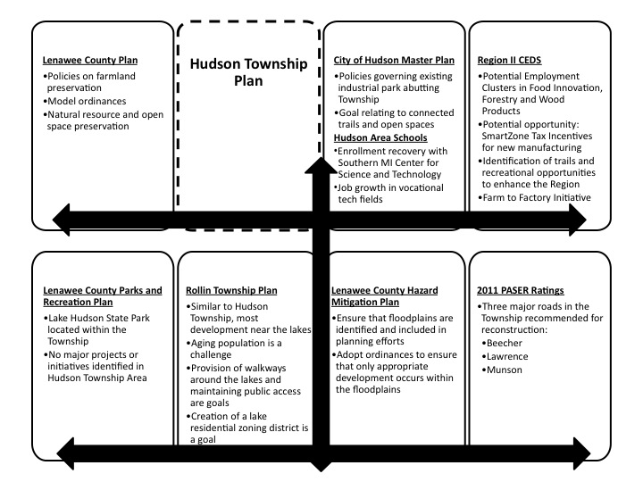

Chart 1- Review of Neighboring Community Plans

Community Input
Throughout the planning process, the Planning Commission sought public input on various topics and issues important to the community. Attendees to Planning Commission meetings were asked to brainstorm ideas and topics that would shape Hudson Township.

Additionally, two community surveys were distributed to residents for input. The first survey asked about the strengths, challenges, and priorities for the Township. The second survey presented policy ideas to residents for review. In both cases, the sample size was less than 10% of the population and not statistically valid. Survey results were used as indicators of the desires of the interested public, not the community as a whole. Full results of both surveys are located in the Appendix.

The first community survey was distributed to residents through tax bills. Thirty-two surveys were collected, representing approximately 2% of the Township population. This survey assisted in identifying existing conditions and issues to be addressed. The general themes from the survey results were:

- Respondents identified the rural, small-town feel of the community, friendly people, and good location on major highways as strengths
- Respondents identified property taxes, costs of maintaining property, and road repairs as challenges
- Respondents seemed concerned about how to maintain the character of the area while providing opportunities for growth and employment
- Respondents felt strongly about preserving farmland and supporting policies that promote small, environmentally friendly farming
- Respondents wanted to protect natural resources
- Respondents identified Beecher Road as a road in need of repair
The second community survey was distributed by the Planning Commission and online through Qualtrics, an online collection source. The survey was administered in the summer and received thirteen responses, representing approximately 1% of the population. This survey focused on policy options to accomplish the vision identified in the first survey. The results are summarized below:
- Respondents wished to maintain policies that support existing agriculture and farms
- Respondents wanted to encourage farms to produce food for local or regional consumption
- Respondents expressed interest in promoting tourism in Lake Hudson, but there was no clear consensus on whether the Township should support these attempts or how it would
- Respondents identified Beecher Road as the road most in need of repair

Opportunities and Constraints
Hudson Township is located in an ideal location of Lenawee County; close to jobs, near major road networks, and distinctly rural in character. The main thoroughfares of US-127 and M-34 provide efficient access to employment centers and interstate trade routes. Future development of industry or commercial is best situated along the US-127 corridor and the area immediately south of the City of Hudson. However, more intense development could strain the road capacity of Hudson Township.
The majority of the Township is most suitable for agricultural purposes. There are opportunities to preserve farmland and continue to develop local and regional agricultural systems. Hudson Township has several natural resources including the Bean and Bear Creek stream systems, and Posey Lake and Lake Hudson. The protection and preservation of natural resources is important for Hudson Township to maintain its character.
Lake Hudson Recreational Area has the potential to develop a countywide trail system. Neighboring communities are interested in developing a trail system. The entrances to Lake Hudson could be developed as recreational commercial centers for small stores related to recreational activities and the Township could work with the State to encourage promotion of Lake Hudson.
Future development in Hudson Township is greatly constrained by its sewer capacity. The sewer is largely built-out and at capacity in the City of Hudson and in the Posey Lake area. Future development could greatly strain the sewer system or threaten natural resources in the Township.

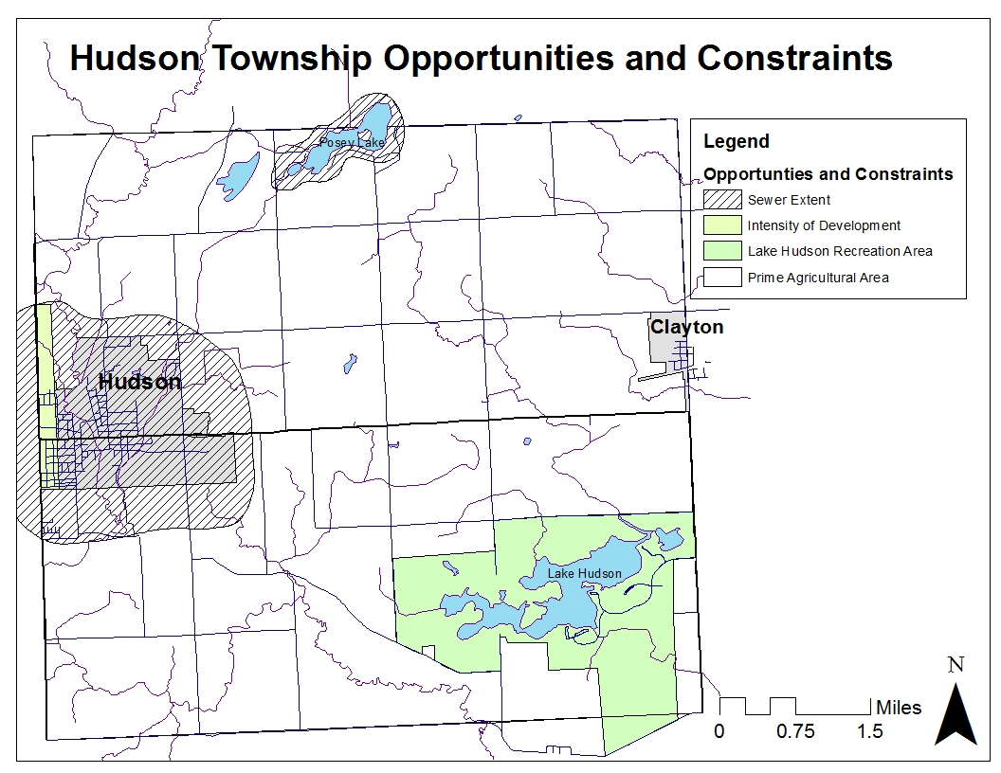

Chapter 3 - Planning Goals and Objectives

The rural, small-town atmosphere surrounded by natural settings is the defining characteristic of Hudson Township. The following goals of Township land use policy seek to preserve this heritage.

Goal: Protect and enhance the agricultural economy which supports the open spaces that define the Township’s land use patterns.
Objectives:
- Preserve land with soils and slopes suitable for agriculture
- Discourage zoning of agricultural land for other land uses
- Allow for agribusinesses and farm support services as land uses within the Township to provide inputs and markets for Hudson farmers
- Collaborate with the Farm to Factory Initiative outlined in the Region 2 Economic Development Plan to encourage agribusinesses in the Region
Goal: Preserve undeveloped land that has scenic value or is an essential component of the local or regional drainage, ground water system, or the wildlife systems.
Objectives:
- Adopt and enforce zoning and nuisance ordinances that protect ground water, lakes, streams, wetlands, forests and wildlife areas
- Build partnerships between owners of ecologically valuable land and land conservancies or other government entities to create land preservation easements or trusts
- Maintain a Lake Residential Zoning District to accommodate the compact residential patterns existing on Posey Lake while protecting the quality and integrity of the lake itself.
Goal: Create a rural community with 21st century services.
Objectives:
- Support Hudson and Morenci Area Schools, Lenawee Intermediate School District and the Southern Michigan Center for Science and Technology to bring education and training for today’s job market to the Hudson Area
- Explore how to bring high-speed internet to Hudson Township, including the use of additional cellular towers
- Advocate to the Lenawee County Road Commission for needed road repairs and maintenance
Goal: Limit non-agricultural land uses to specific areas in Hudson Township with the appropriate road, water and sewer infrastructure.
Objectives:
- Cluster commercial land uses at strategically defined points within the Township, having location on adequate roads and near concentrations of population.
- Locate industrial development where adequate services and appropriate facilities are available and where they will not have an adverse effect on adjacent natural features, residential homes or agricultural operations.
- Plan for full use of current industrial buildings and possible expansion for the developing skilled work force in Hudson
- Maintain single-family residential areas in places with adequate services, such as fire, police and schools, as well as infrastructure.
Goal: Bring tourism to Hudson Township.
Objectives:
- Partner with the State of Michigan to improve and advertise Lake Hudson Recreation Area
- Work with Lenawee County and surrounding municipalities to create recreation trails
- Plan for expanded commercial recreation areas around the Lake Hudson area to provide services to visitors

Chapter 4 - Future Land Use
The Master Plan assists the Township in future land use. The Master Plan includes a map of intended land use as well as a discussion of what each of the land use categories are in the Township. While the land use map is not permanent, it does provide orderly development in a strategic way so that there are no undue burdens on residents, commerce, developers, or industry should new land use arise.

The future land use for Hudson Township falls into the following categories:

Agricultural (A) - The purpose is to preserve land containing agricultural value, support a relationship between urban and rural environments, create rural character, permit land allotments for urban purposes to support new public utilities, and discourage the development of agricultural lands that adversely affects remaining agricultural endeavors by increasing land values.

Residential (R)- The purpose of the residential area is to encourage the construction of, and the continued use of the land for single-family dwellings, prohibit business, commercial, or industrial use of the land, and to prohibit any other use that would substantially interfere with development or continuation of single-family dwellings in the district. Residential land should only be allowed where roads, fire and police, water supply, and sewerage has the ability to support it.

Lake Residential (LR) – The purpose of Lake Residential is to accommodate the existing compact residential development in the vicinity of Posey Lake. New construction should be compatible with the existing residential character of the area and maintain minimal traffic on local streets.

Manufactured Housing (M) – The purpose of this area is to provide a suitable environment for persons and families who choose to live in a manufactured housing development.

Commercial (C) – The commercial area permits business and service uses which are needed to serve the nearby residential areas. Business areas should be clustered for the best use of land at certain strategic locations and to avoid the strip, business development along heavily traveled roads.

Commercial Recreation (CR) – The purpose of commercial recreation area is to promote seasonal outdoor recreation uses and preserve the natural features of the land, maintain adequate space for off-street parking facilities to serve large numbers of people, and to permit other commercial uses in conjunction with the recreational uses.

Industrial (I) – The purpose of industrial area is to permit light manufacturing industries in planned areas of the Township, and to integrate those industries with nearby land uses such as commercial and residential.

Future Land Use Category | Zoning Category
Agricultural | A
Residential | R
Lake Residential | LR
Manufactured Housing | M
Commercial | C
Commercial Recreation | CR
Industrial | I

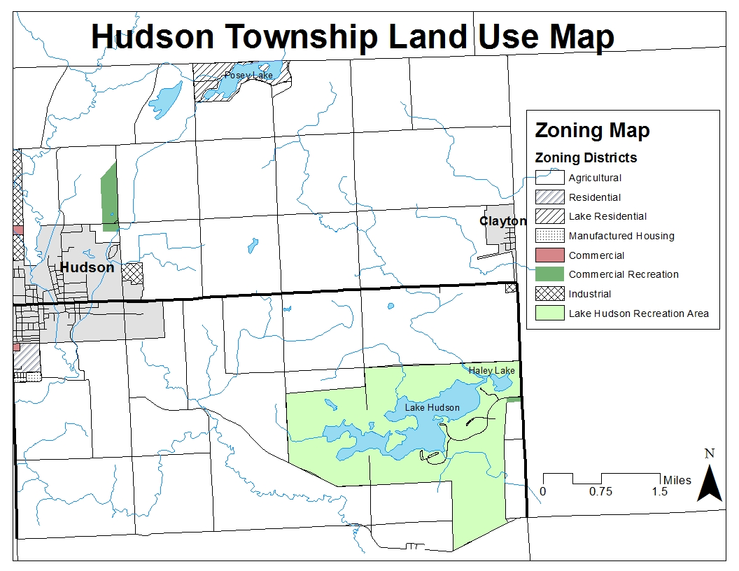
Future Land Use Map

Chapter 5 - Implementation
The previous chapters outline the state of the Township, goals and objectives of the citizens and Planning Commission, and a framework for future land use in Hudson Township. All goals require action items to ensure that adequate progress is made. The following summarizes each goal and provides action steps to progress toward the goal.
Preserve and Protect Agricultural Economy
The agricultural character is the heart and soul of Hudson Township. It is important to all members of the community to protect and enhance agricultural efforts throughout the Township. Several steps can be taken to achieve this goal:
Preserve Agricultural Land
Neighboring community plans seek to preserve agricultural land. The Region 2 Economic Development Plan seeks to encourage and support agribusiness in Lenawee County. Hudson Township should work to capitalize on this momentum, particularly in the Farm to Factory Initiative.

Discourage Zoning Agricultural Lands for Other Purposes
While it may be tempting to zone land for other purposes, agricultural lands are important to Hudson Township’s economy, history, and character. The land use plan suggests that new land uses should be concentrated near existing developments.

Preserve Natural Resources and Undeveloped Land

Natural resources are an essential part of Hudson Township, including the river and stream systems, and the two major lakes, Posey Lake and Lake Hudson. Ecologically valuable land will maintain the rural character of the community and continue to protect natural resources if protected.

Adopt and Enforce Nuisance Laws
Nuisance law can assist in the protection of natural lands and ensure that ecologically important lands are used for their natural purposes. Enforcement of the nuisance law will ensure that natural lands are used in ecologically protective ways.

Build and Maintain Partnerships for Land Easements or Trusts
Collaborating with neighboring communities and Lenawee County can assist with the collection of land into land easements or trusts to preserve ecologically valuable lands.

Maintain Lake Residential Zoning District
Lake Residential Zoning ensures that compact development continues on Posey Lake and that lands are being used in ways to maintain the ecological integrity of the lake.
Create a Rural Community with 21st Century Services

Hudson Township can continue to maintain the rural character of the area while upgrading services to meet 21st century needs. Access to workforce development, quality roads, and high-speed Internet are essential to ensure Hudson Township maintains the quality of life that its residents have come to know.

Coordinate with Southern Michigan Center for Science and Technology
The Planning Commission can work to ensure that plans developed by Hudson Area Schools and the new Southern Michigan Center for Science and Technology are supported by zoning and development. New areas for industry on suitable lands could be supported through the land use plan.

Upgrade High-Speed Internet Access
To support new industry, greater access to high-speed Internet is essential for Hudson Township to compete with neighboring communities. Mobile Broadband is widely available throughout the Township, but additional cell phone towers would be required to support a complete network.

Advocate for Road Repairs
To support new industry in Hudson, coordination and collaboration with the County Road Commission is essential to ensure high priority roads are updated. Beecher, Lawrence, and Munson Roads have been identified as high priority roads and are supported by community input as roads in need of upgrades.

Limit Non-Agricultural Uses to Appropriate Areas

Hudson Township cannot adequately support more intensive uses in many areas of the Township. Additional space for industrial, commercial, or residential uses should be limited to areas in the Township that adequately provide for these uses.

Concentrate Commercial and Industrial Uses
Commercial and Industrial uses should be concentrated along corridors where these uses are most suited, notably along US-127, shown on the land use map.

Industrial Development
Existing industrial land should be filled first and then preparations can be made for more. Industrial uses should be concentrated along identified corridors or near existing areas of industry that have less adverse effects on environmental conditions. As the workforce becomes trained for new industry, the Master Plan can be revised to allow more industrial uses in appropriate locations.

Maintain Single Family Residential
If additional housing is proposed, single-family residential units should be maintained near areas of population with adequate access to services, such as sewer, police, and fire.
Bring Tourism to Hudson Township

Community survey responses indicate that there is a desire for more tourism and recreational opportunities. Neighboring communities have plans to enhance or create trail networks that could include Hudson Township. The Township should capitalize on the enhancement of recreation in the Township for both citizens and a small economy tourist economy.

Enhance Lake Hudson Recreational Area
Hudson Township can work with the State of Michigan to encourage enhancements at the Lake Hudson Recreational Area. Additional support could come in the form of recreational trails, enhancements to the recreational area, or promotion from the state for more tourist opportunities.

Establish Trail Network in Lake Hudson
Lenawee County and several neighboring communities are looking to create a trail network. Hudson Township has a chance to connect to these trails and enhance the trail network in the entire region.

Encourage Tourist and Recreational Development
Areas near the entrance to Lake Hudson Recreational Area could be developed into small shops to support the tourist economy. The future land use map designates areas that could be considered for zoning to allow these uses.

Implementation Tables
The following tables provide suggested timelines to make adequate progress toward the goals set forth in the Master Plan. These tables are not mandatory guides, but brief descriptions of what organization or organizations need to be involved to accomplish goals in the Master Plan. The timeline provides milestones for progress, but can be adjusted as opportunities arise in the Township. With these goals and strategies in mind, the Planning Commission can engage with groups that are pursuing similar goals when the time is appropriate.

Protecting and Enhancing Agricultural Economy
Strategy | Group Responsible | Timeline
Preserve land with soils and slopes suitable for agriculture | Planning Commission | Ongoing
Discourage zoning of agricultural land for other uses | Planning Commission | Ongoing
Allow for agribusiness and farm support services as land uses in the Township | Township Board and Planning Commission | 1-2 Years
Collaborate with Farm to Factory Initiative, outlined in Region 2 Economic Strategy Plan to encourage agribusiness to locate in region | Township Board in conjunction with Region 2 Planning Commission | 1-2 Years

Preserve Undeveloped Land with Scenic Value
Strategy | Group Responsible | Timeline
Adopt and enforce nuisance ordinances to protect natural resources | Planning Commission | Ongoing
Build partnerships with owners of ecologically valuable land to establish land preservation easements or trusts | Planning Commission and Township Board | 1-3 Years
Maintain Lake Residential Zoning District to accommodate compact residential patterns on Posey Lake while protecting quality and integrity of the lake | Planning Commission | Ongoing

Create a rural community with 21st century services
Strategy | Group Responsible | Timeline
Support collaboration between Hudson Area Schools, Lenawee County ISD, and Southern Michigan Center for Science and Technology to bring education and training for today’s job market to area | Planning Commission and Township Board | Ongoing
Explore how to bring high-speed internet to Hudson Township, including use of Mobile Broadband via cell towers | Township Board | 1-3 Years
Advocate to Lenawee County Road Commission for needed road repairs and maintenance | Township Board and Planning Commission | Ongoing

Limit non-agricultural land uses to specific areas in Township with appropriate infrastructure
Strategy | Group Responsible | Timeline
Cluster commercial land uses at strategically defined points within the Township, located near adequate roads and concentrations of population | Planning Commission | Ongoing
Locate industrial development where adequate services and facilities are available and where they will not have an adverse effect on natural features, residential homes, or agricultural operations | Planning Commission | Ongoing
Plan for full use of current industrial buildings and potential expansion due to developing skilled work force | Planning Commission | As proposed
Maintain single-family residential areas in places with adequate services and infrastructure | Planning Commission | Ongoing

Bring Tourism to Hudson Township
Strategy | Group Responsible | Timeline
Partner with State of Michigan to improve and advertise Lake Hudson Recreational Area | Planning Commission and Township Board | 1-3 Years
Work with Lenawee County and surrounding municipalities to create recreation trails and trail network | Planning Commission and Township Board | 1-3 Years
Plan for expanded commercial recreation areas around the Lake Hudson area to provide services to visitors | Planning Commission | Ongoing

Appendix

Table 2 – Population Change in Hudson Township and selected areas, 1970-2010. Source: US Census 2010.

Area | Percent Change
 | 1970-1980 | 1980-1990 | 1990-2000 | 2000-2010
Hudson Twp | 20.9% | -6.1% | 7.9% | -5.6%
Surrounding Townships | 10.3% | -1.8% | -1.5% | -1.5%
City of Hudson | 0.0% | 1.4% | -3.1% | -7.7%
Village of Clayton | -15.6% | 0.5% | -11.7% | 3.6%
Hillsdale/Lenawee County | 17.3% | 2.2% | 7.8% | 0.8%

Chart 2- Population Change in Hudson Township and selected areas, 1970-2010. Source: US Census 2010.
